1. Norway has a sugar tax that is a tax paid on chocolate and sugar products that are either imported into Norway or produced in Norway. In 2016 the tax was around 20 Norwegian knorer (NOK) per kg.

Consider the market for candies in Norway before the introduction of this sugar tax. Market demand and market supply curves are given by the following equation below where P is the price in NOK per kg of candies and Q is the quantity in kg of candies:

Market Demand: P = 125 – (3/8) Q

Market Supply: P = 5 + (1/8) Q

1. Given the above information, find the equilibrium price and quantity in this market.

At the equilibrium point, Demand= Supply

Quantity Supply= Quantity Demand

Price of Supply= Price of Demand

125 – (3/8) Q= 5 + (1/8) Q

So, Q\*=240

P\*= 5+(1/8) (240) = 35

1. Calculate the values of consumer surplus and producer surplus before the imposition of the tax. Show them graphically in a well-labeled graph.

Demand: P = 125 – (3/8) Q

If Q=0, P=125

Market Supply: P = 5 + (1/8) Q

If Q=0, P=5

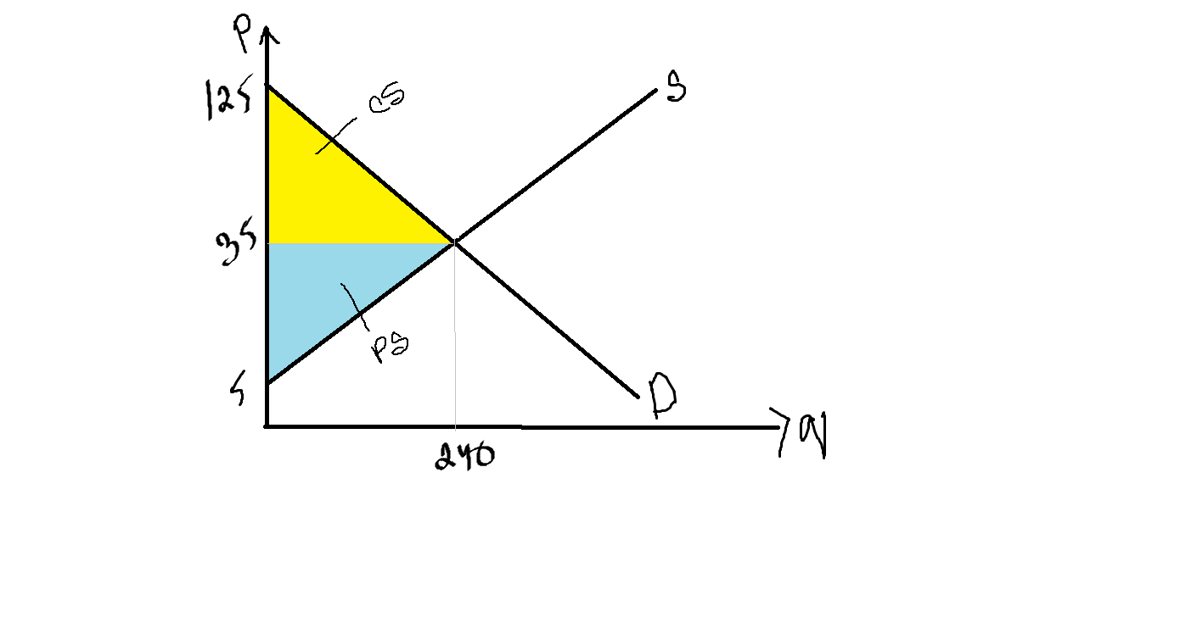

Consumer Surplus=½ x 240 x (125 - 35) = 10, 800

Producer Surplus= ½ x 240 x (35-5) = 3, 600

Total Surplus = 14, 400

1. Given this excise tax of 20 Norwegian knorer, find the new price consumers will pay for each kg of candies, the new price producers will receive for each kg of candies after they pay the excise tax, and the new equilibrium quantity of kg of candies that will be sold in the market. Show the impact of this excise tax in a well labeled graph.

Market Supply without tax: P = 5 + (1/8) Q

After tax of 20 NOK per unit is imposed, supply shifts by 20 NOK:

Supply equation after tax= >

PT=P+20

PT= 5+(1/8) Q+20

PT= 25+(1/8) Q

Market demand: P = 125 – (3/8) Q

For the new equilibrium point, Supply after tax = demand

PT=P

25+(1/8) Q = 125 – (3/8) Q

Q\* after tax=200 (New Equilibrium quantity after tax)

P\*=25+(1/8) 200=50 KOR (Consumer is paying 50 KOR)

Price that producer will receive after 20 KOR tax=50-20=30 KOR

To draw the new supply graph:

PT= 25+(1/8) Q

Q=0, PT=25

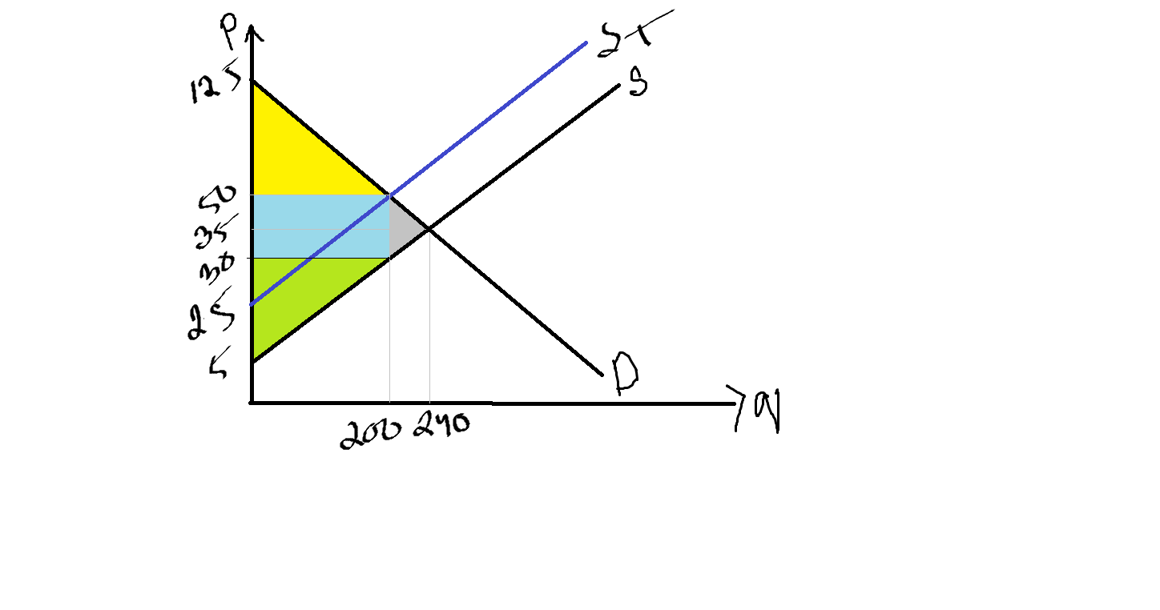

1. Given this excise tax, calculate the value of consumer surplus with the tax, producer surplus with the tax, tax revenue the government receives from implementing the tax and the total economic welfare loss due to this intervention and show the loss using a demand-supply diagram.

Consumer Surplus after tax= ½ x 200 x (125-50) = 7, 500 NOK

Producer surplus after tax=½ x 200 x (30-5) = 2, 500 NOK

Tax revenue=20 X 200= 4000 NOK

DWL=½ X (50-30) X (240-200) = 400 NOK

Total Surplus after tax= 14, 000 NOK

Another way to find DWL is= Total Surplus before Tax- Total Surplus after tax=14, 400-10,000=400 NOK

2. Consider the market conditions for the single-price monopoly shown in the diagram below:

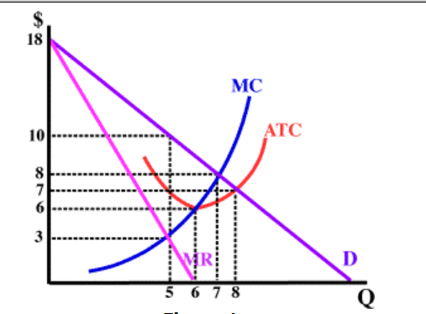

1. What is the profit maximizing price and quantity of the firm.

At profit maximization point=MR=MC

Quantity=5, price=10

1. Calculate the deadweight loss due to the monopolist’s market power.

DWL=½ X (7-5) X (10-3) = 7

1. Suppose the market acts as a perfectly competitive market, determine the profit maximizing price and quantity for the market.

The demand line is the MR line

Price=8

Quantity=7